Unite 1 : Partnership and limited liability
« The end of law is not to abolish or restrain, but to preserve and enlarge freedom, where there is no law, there is no freedom. »
John Locke, English philosopher and physician
1632-1704



Partnership is a business arrangement in which several people work together and share the risks and profits. The partners are fully liable for any debts the business has. Furthermore, in case of legal action, it's the individual partners who will be taken to court. A sole trader business is an enterprise owned and operated by a single person and has also a limited liability.
The company is a legal entity that has a separate legal existence from its owners. It can enter into contract, and can be sued or taken to court if it breaks a contract. In theory, a company can continue forever, even if all the staff and owners change.
Most companies have limited liability which means the owners are not fully responsible for business debts. Their liabilities are limited to the value of their share capital. This limitation of liability encourages people to invest their capital in the company as they incure no risk. These kind of companies are known as limited companies.
Shareholders do not manage their company, this mission is entrusted to managers and executives directors. The way a company is run and how managers are accountable to shareholders is called : corporate governance.The company is controlled by a board of directors which do not work in full time. Its members offer their advice, review decisions taken by managers and inspect the efficiency of the results achieved by them.
Shareholders can meet directors in the AGM (Annual general meeting), they question them about the content of the annual report, vote to accept or reject the dividend recommended by the directors and vote on replacements of retiring member of the board. The meeting can also carry out any other business stated in the memorandum of association. If there's a crisis, directors and shareholders can request to hold an extraordinary general meeting (EGM) to discuss the situation.
Comprehension : Say if these statements are true or false. Correct the wrong ones.
- In case of legal conflicts, people can sue shareholders.
- The owners of a Partnership have to pay all company's debts.
- Managers are the owners of company they work in.
- External directors are allowed to control the management of the company.
- Executive directors are members of the board of direction.
- Shareholders vote for the amount of dividends in the EGM.
Vocabulary :
Exercise 1 : make word combination using words from A and B, then make the correct combinations to definitions below.
A : Corporate – Audit – Limited – Non executive – Share
B : Commitee – Directors – Governance – Cpital – Liability
………………………… :a group of directors to whom external auditors present their report.
………………………… : money owned by investors in a company.
………………………….. : the way shareholders control management of the company.
…..…. . ..……………...... :group of accountants in charge of inspecting company's accounts.
………………………….. : shareholders are not responsible for the company's debts.
Exercise 2 : find in the text synonyms of all these words : deal, completely, in addition,
Grammar : Pronouns : this/that, these/those
Here are cases where we use these pronouns
Cases | Examples
We use this (singular) and these (plural) to talk about people or things near us | This is a nice cup of tea  Whose shoes are these ?
To introduce people | This is Janet  These are my friends : John and Michael  Note : we don't say : these are John and Michael, we say : this is John and this is Michael.
To introduce ourselves to begin a conversation on the phone. | Hello, this is David, can I speak to Sally ?
We use that (singular) and those (plural) to talk about things or people that are not near us | What's that ?  This is our house and that's rebecca's house over there.
We use that to refer back to something someone said or did | Can we go to the cinema ?  - Yes, that's a good idea.  I've got a new job : That's great  I'm very tired : Why is that ?
Unite 2 : Private and public company
« Price is what you pay, Value is what you get »
Warren Buffett, Businessman, 1930.

When people found a company, they prepare articles of association and a memorandum of association. The articles of association state :
- The rights and duties of the shareholders and directors
- The relationship between shareholders and the company and its directors.
The memorandum of association states :
- The company's name,
- The location of the company's registered office, where to send official documents.
- The authorized share capital, the maximum share capital it can have.
Private companies have «ltd » at the end of their name. Public limited companies have «plc » at the end of their name. In US law, companies or corporations are registered with Securities and Exchange Commission (SEC) and known as listed companies. SEC registered companies have to make quarterly reports (every three months). They report on :
- Sales revenue or turnover – the money received by the company in that period from selling goods and services.
- Gross profits – turnover less costs of sales.
- Net profit – gross profits less administrative expenses and taxes.
Companies on the London stock exchange, known as quoted company have to produce a half yearly report which informs the shareholders about the company's progress. These reports are not audited.
At the end of the year, all companies send their shareholders the financial annual report. It contains a review of the year’s activity and the explanation of its position and results. It also includes financial statements and notes.
Comprehension :
- What are the two main documents prepared by people to found a company ?
- What is the difference between «ltd » and « plc" ?
- What is the meaning of listed companies ?
- Do companies have to produce a unique report ?
Vocabulary : match the two parts of a sentences
- Only listed or quoted companies,
- American corporations publish details
- Companies’ financial statements and auditor's report,
- Quarterly and six monthly reports,
- Shareholders can ask company directors questions,
- Companies can hold an emergency general meeting,

  - About their sales and profits every three months
  - Are contained in their annual report.
  - Are not checked by external auditors.
  - If there's a crisis.
  - Can have their shares traded on the stock exchange.
  - At an annual meeting.
Grammar : Present Simple
- Find in the text verbs in the present simple ?
- Do you think that the actions of the verbs are happening now ?
Here are how we write verbs in present simple
Cases | Examples
With : she, he, it : we add s | The memorandum of association states that :……
In the negative form, we add the verb do + not /does + not | Shareholders do not manage their company.
In the interrogative form | Do the directors meet next week ?
Verbs ending in y, with third person, the y changes into ies | To cry – he cries
If there's a vowel before y, we just add : s | he plays  she enjoys
Verbs ending in : ss – ch – sh – x, we add es | He passes, she catches, it fixes, it pushes.
The present simple is not used to express actions happening now, we rather use present continuous. The present simple is used only in these cases :
To express :  - Habits,  - General truths,  - Unchanging situations,  - Emotions and wishes | - I smoke.  - General motors is a big company.  - I take the bus every day.  - I wish I can find a job.
To give instructions and directions | You walk for two miles then you turn left
To express fixed arrangement present or future | Your exam starts at 9.00
To express future time after some conjunctions :after, before, until, when, as soon as. | We will give it to her once she arrives.

Exercise 1 : check the correct answer
- My father still …………….. the same newspaper every day. (Buys, bought, is buying)
- The relative humidity usually ………………. when the temperature goes down. (Fells/falls/will fall).
- My best friend………………. in that apartment building over there. (Lives/is living/live).
- What is the name of the picture, you ……………….at on the wall ? (look, are looking, looks)
- ………………. … . to meet them ? (Are you going/do you go)
- ………………….. everything he says ? (Do you believe/are you believing)
- I'm so glad that you……………… us. (will join/joined/join).
- I will not leave until I……………. to your boss. (talk/talks/will talk).
- Later tonight, I…………….. him (call/am calling/will call).
- Why………….. always late ? (is she/she is being/she is) ?
- Your meeting ……………….. at 11.00 (starts/will start/start)
- You go through in-house then you……………. Right. (turns/will turn/turn).

Unite 3 : Company’s Terminology
Match the following items related to company with their appropriate definitions.
Company act | The title by which an incorporated firm is known as a legal entity or artificial-person.
Company creed | A law made by Parliament which regulates the workings of companies, stating the legal limits within which companies may do their business.
Company law | A statement made by the company which shows how to conduct its business and dealing with its various stakeholders.
Captive finance company | Firm over which another firm exercises a degree of control which is less than the degree of control exercised over a subsidiary. In accounting, such control require the ownership of at least 20 percent of voting shares.
Company policy : | Incorporated firm with share capital
Company name | Legislation under which the incorporation, registration governance, and dissolution of a firm is administered and controlled.
Brasseplate company | Incorporated firm without share capital, and in which the liability of its members is limited to the amount each one of them undertakes to contribute at the time the firm is wound up.
Company limited by guarantee | A written document that shows to employees how the company is organized.
Company limited by share | A legal firm without any 'real' existence especially in tax havens.
Limited company : | A company that offers limited liability, or legal protection for its shareholders but that places certain restrictions on its ownership in order to prevent any hostile takeover attempt. These restrictions are: shareholders cannot sell their shares without offering them first to other shareholders for purchase, shareholders cannot offer their shares to the general public over a stock exchange, and the number of shareholders cannot exceed a fixed figure (commonly 50)
Private limited company : | Wholly owned subsidiary that finances activities of the parent firm. For example, firms such Ford, General Electric have their own finance companies.
Associate company | incorporated limited liability firm whose share capital is restricted by its memorandum of association.
Grammar : The possesive form
Possessive nouns are used to show ownership or belonging to. Ownership is the act of owning or having something.

Cases | Examples
If the noun is singular, we add s | The car of this man = This man’s car
If the noun is singular but ends in s, we add either s or just ‘, and it sounds z | The book of Charles = Charles's book, Charles’book.  The company of the boss = the boss's company.
If the noun is plural, we use ‘ | The room of the girls = girls’room
If two people own something, we add s to the second person only | The house of John and George = John and George's house
If two people own separate things, we add s for each person. | The office of the director and the office of the assistant = Director’s and assistant’s offices
If a plural noun does not end in s, we add s | The work of these women = these women's work.
To refer to shops, restaurants….. | I'm going to the Mcdonald’s

Unite 4 : Talking in a Meeting or in a negotiation
« Wise men speak because they have something to say, fools because they have to say something »
Platon, Classical Greek Philosopher, 427-347 BC

The two pictures below show people holding a meeting, what the difference between them ?


When talking to people, do you think them always concentrate or good listeners ?



Grammar : Pronouns
A pronoun usually refers to a something already mentioned in the text in order to avoid repetition. Here are all kinds of pronouns :
Subject | I | You | He | She | It | We | They
Object | Me | You | Him | Her | It | Us | Them
Possesive adjective (determiner) | My | Your | His | Her | Its | Our | Their
Possesive pronouns | mine | Yours | His | Hers | Its | Ours | Theirs
Reflexive and intensive pronouns | myself | Yourself  Yourselves | Himself | Herself | Itself | Ourself  Ourselves | Themselves
Notes :
- You is used both for singular person or more than two (male or female).
- It and they are also used for male or female.
- We can be used either as I in formal speaking and writing
1- Subject Pronoun can be a subject as it can replace the noun which is the subject of the sentence.
- We work together on this project
- Managers should achieve the target, they have to work very hard.
There's often confusion over which pronoun you should use when you're one half of a dual subject or object.
- Should you say : « me and him had a fight » or « he and I had a fight » ?
If we write the sentence with one pronoun we will say : « I had a fight », not «me had a fight ». Same things goes to the object. We said «the police arrested me and him», not « the police arrested I and he »
2- Object Pronouns are used to replace nouns that are the direct or indirect object of the clause. Give the book to me. Tell them to come.
3- Possessive adjective : they are not pronouns but determiners, it's useful to learn them at the same time as pronouns because they are similar in form to possesive pronouns. Possesive adjective appear before the noun they modify, do not replace it as pronouns do. The noun is the thing being possessed. The chief wants to read our report.
4- Possesive pronouns : do not come before the noun, they replace it and used alone. You have your book, I have mine.
5- Reflexive and intensive pronouns : Reflexive pronouns refer back to the subject because the subject of the action is also the direct or indirect object. Only certain types of verbs can be reflexive. You cannot remove reflexive pronoun from a sentence because the remaining sentence will be grammatically incorrect. I told myself to calm down.
Intensive pronouns emphasize the subject of a clause. They are not the object of the action. They can be removed without changing the meaning of the sentence. Intensive pronouns can be placed immediately after the subject or at the end of the sentence. I made these cookies myself.
Exercise : here are parts of conversation, check the right pronoun
- So did you give the book to………..(his/he/him) ?
- Of course I did, I gave………back on Tuesday (it/them/its).
- Well, he says that he doesn't trust………..(them/you/yours)
- He doesn't trust……….(I/me/mine) ?!!!
- That's exactly what he said about………..(it/you/yours)
- I can't believe that, do you trust…………..(me/my/mine) ?
- Well, you and your wife have borrowed things sometimes and not given…… …….. back (them/their/they) ?
- I think you are very unfair to ……………(us/we/ours) ?
- In that case, look at the table and tell…………… what you see ? (I/me/my)
- Oh sorry, ………….(you, your, his) book is still here, I thought I have given back to………….. (them, him, you).

Unite 5 : People in meeting
« Nearly all men can stand adversity, but if you want to test a man's character, give him power. »
Abraham Lincoln, 16th President of the United states
1809-1856

Some animals in the forest decide to hold a meeting in ordre to discuss how to kill their king or any other issu. Look at the picture and try to answer questions below :
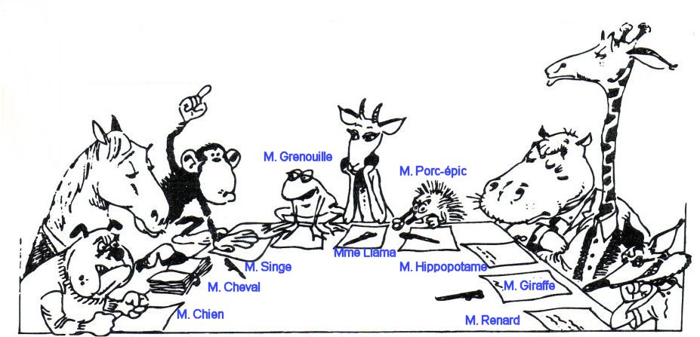
These 9 animals, according to their character, represent the kinds of people, one can expect to deal with in any meeting. So here are names of these animals, match each one with the appropriate person it may represent, according again to its character.
Talkative Dog
Sorehead Horse
Wise Monkey
Foxy Frog
He knows everything Gazelle
Lord Porcupine
Brawler Hippotamus
Tender Giraffe
He’s against Fox

Now try to find how to behave face to each person. Select the appropriate strategie to adopt with participants.

1.Keep calm, do not provoke him He knows everything
2.Take advantages of his orientations Sorehead
3.Encourage the group to undermine his theories Wise
4.Interrupt him with tact, try to limit his speaking time Foxy
5.Make him more confident, ask him easy questions and Talkative
be impressed about each interesting thing he said
6. Limit your discussion with him Lord
7. Pay attention to his favourite topics Brawler
8. Do not criticize him, use « Yes, but…. » to say no Tender
9. Foil his plan and argument He’s against
Now imagine that other animals join the meeting like : a cat, lion, parrot, bear, chameleon, shark. What could be their character.
- He waits for the others to bring what to eat.
- He’s not sociable.
- He falls on his paws.
- He changes his minds easily.
- He repeats all what he heard.
- Predator, his presence is just for himself.
One can have to deal with very different people, in work or in daily life, not just in meeting. It’s important to know what are their characters in order to have the appropriate behavior. In company, the aim is to avoid conflits and reach agreement that could meet employees’ expectations.

Unite 6 : Money and income
« Don't think money does everything or you are going
to end up doing everything for money. »
Voltaire, French writer, 1694-1778

The money used in a country is its currency. Money in notes and coins is called Cash. Most money, however, consists of bank deposits, money that people and companies have in their accounts. As payments and transactions are done by means like cheque or credit cards, there is only about 4 per cent of money existing in the form of cash in European union. In other country like Tunisia, this percentage do not exceed 12 per cent. In Algeria, however, it's about 25 per cent.
Income is all the money a person receives or earns and it can include :
- A salary : money paid monthly by an employer, if it's paid by the day or by the hours, it's called wages and usually received weekly.
- Overtime, money received for working extra hours.
- Commission : money paid to salespeople or agents and it corresponds to a certain percentage of personal incomes.
- A bonus : extra money given for meeting a target or for good financial results.
- Fees : money paid to professional people such as lawyers or architects.
- Social security : money paid by government to unemployed or sick people.
- Pension : money paid by a company or the government to retired people.
Salaries and wages are often paid after some deductions such as social security charges and pensions contributions. Amount of money that people have to spend regularly are called outgoings. These often include :
- Living expenses : money spent on everyday needs such as foods, clothes and public transport.
- Bills : requests for the payment of money owed for services such as electricity, gas and telephone connections.
- Rent : the money paid for the use of a house or a flat.
- A mortgage : repayment of money borrowed from the bank to pay a house or a flat.
- Health insurance : financial protection against medical expenses for sickness or accidental injuries.
- Taxes : money paid to finance government spending.
Comprehension :
- What is the difference between salary and wage ?
- When can someone expect to earn overtime ?
- What is the difference between social security charges and health insurance ?
Vocabulary :
Exercise 1 : Fill in the gaps with the appropriate words : Commission - earn- currency -salary- bonus- mortgage- pension-taxes-overtime- rent – social security.
- After I lost my job, I was living on ………………………………for three months. It was very difficult because the amount was much lower than the…………………..I had before.
- I used to work as a salesman but I wasn't very successful, so I didn't…………………………..much………………………
- If the company makes 10 % more than last year, we all get a ………………………. At the end of the year.
- It will take me at least 25 years to repay the…………………on my house.
- Many European countries now have the same………………….., the euro.
- My wages aren't very good so I do a lot of……………………
- Nearly 40 % of everything I earn go to the government as………………….
- The owener has just increased the………………. On our flat by 15 %.
- When I retire, my……………………..will be 60 % of my final salary.
Grammar : Relative/Indefinite pronouns.
Relative pronouns relate group of words to nouns or other pronouns.
That and which can only refer to things
Who and whom can only refer to people.
Who is used as a subject of the sentence, whom is always the object of a verb or a prepositional phrase.
The secretary gave three boxes to the mailman who entered the office
He doesn't know whom to assign to the task force.
Indefinite pronouns function as nouns but they do not replace it. They are everybody and some.
Everybody admires his speech.
Any word with every (everyone, everything….) is singular, not plural. Therefore it needs singular pronouns, not plural.
Everybody needs to be on time in his office (it's not correct to use their instead of his)

Unite 7 : Accounting and accountancy
« Accounting does not make corporate earnings or balance sheets more volatile. Accounting just increases the transparency of volatility in earnings. »
Diane Garnick, American Businessman, 1967


Accounting involves recording and summarizing an organization's transactions or business deals such as purchases or sales and reporting them in the form of financial statements. In many countries, accounting and accountancy profession has a professional organizations which operate their own training and examination systems, and make technical and ethical rules. These relate to accepted ways of doing things. Bookkeeping is the day to day recording of transactions.
Financial accounting includes bookkeeping and preparing financial statements for shareholders and creditors (people and organizations who have lent money to the company).
Management accounting involves the use of accounting data by managers, for making plans and decision.
Auditing means examining a company's system of control and the accuracy of its records looking for errors or possible fraud, where the company may have deliberately given false information.
- An internal audit is carried out by a company's own accountants or internal auditors.
- An external audit is done by independent auditor who are not employees of the company.
The external audit examines the truth and the fairness of financial statements. It tries to prevent what is called creative accounting, which means recording transactions and values in a way that produces a false result, usually an artificially high profit.
Comprehension :
- Do you think the accountancy profession independent ?
- What is the role of professional accountancy organization ?
- What is the difference between internal and external audit ?
Vocabulary : when writing accounts and financial statements, accountants have to follow a set of principles. As you are students in accounting, you have probably studied these assumptions, read definitions below and match each one with its meaning.
- Materiality
- Objectivity
- Separate entity
- Unit of measure
- Full-disclosure
- Time period
- Conservatisme
- Matching principles
- The revenue recognition
A. A business is an accounting unit separated from its owner, creditors and managers and their assets. These people can all change but the business continues as before.
B. The economic life of a business can be divided into artificial periods such as a financial year or a quarter of it.
C. All financial transactions are in a single currency. Companies with subsidiaries in different countries have to convert their results into one currency in a consolidated financial statement for the whole group of companies.
D. Financial reporting should include all significant informations, anything that makes a difference to the users of financial statements.
E. Very small and unimportant amounts do not need to be shown.
F. If there are different accounting methods, you choose the one that is least likely to overstate or over-estimate assets or income.
G. Accounts should be based on facts, not on personal opinions or feelings. Accounts should be verifiable. Internal or external auditor should be able to recognise that they are true. This isn't always possible, depreciation and amortization or provisions for bad debts, for example, are necessarily subjectives, based on opinions.
H. The revenue is recognised in the accounting period in which it is earned. The revenue is recorded when a service is provided or when good is delivered, not when they are paid for.
I. Each cost or expense related to revenue earned must be recorded in the same accounting period as the revenue it helped to earn.
Grammar : Reflexive pronouns
Here are 4 cases where we should use Reflexive pronouns.
1. We use a reflexive pronoun with transitive verbs, as a direct object when the object is the same subject of the verb :
- Be careful with that knife, you might cut yourself
The most common transitive verbs are : enjoy, dry, amuse, blame, hurt, introduce, prepare, satisfy…. We do not use Reflexive pronouns after verbs which describe things people do obviously for themselves : dress, shave, wash.
- He always shaves himself before going to work.
We only use Reflexive with these verbs for emphasize :
- She dressed herself in spite of her injuries
2. We use Reflexive pronouns as an indirect object when the object is the same as the subject.
- We have brought ourselves something to eat.
3. As an object of a preposition when the object refers to the subject of the clause.
- He was feeling very sorry for himself.
4. With the preposition by if we want to show that someone did something alone.
- he walked home by himself
- she lived by herself in an enormous house.
5. To emphasize the person or thing we are referring to.
- the Chairperson himself gave me the gift.
Note : we don't use Reflexive pronouns after a preposition of place :
- He had a big opportunity beside him.
After with when it means accompanied by :
- I have few friends with me.
Writing : fill in the gaps with the appropriate word.
- Every transactions made by the company must be………………… There must be a document to show that it's true.
- Multinational with its subsidiaries, combines all their results in a set of……………………………
- Both internal and external auditors have to ………………company's accounts.
- Despite the……………....principle, accountants have to make some subjective judgment.

Unite 8 : Accounting policies and standards
« Accounting as a discipline is the focus of constructive debate and intensive rethinking caused by economic and technological change, and one that will continue to involve in the future »
Accounting education Change Commission (AECC)
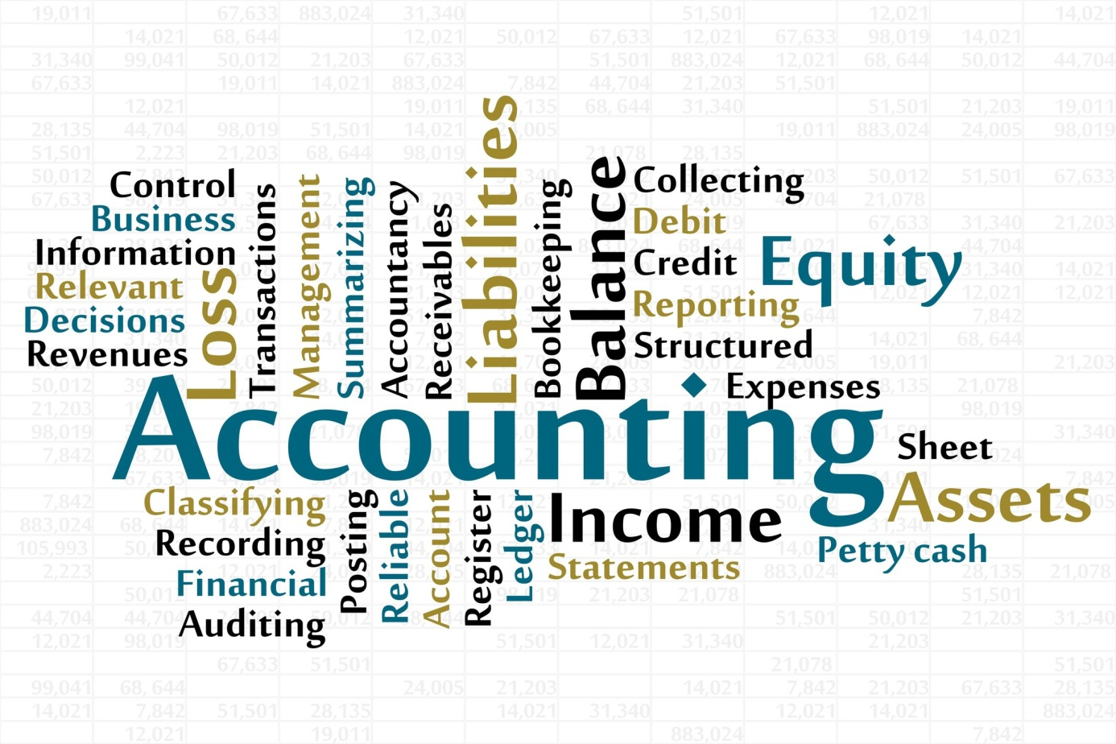
Companies can choose their accounting policies – ways of doing accounts – in order to know how much the company is worth, and to calculate their profits. In the USA, there are Generally Accepted Accounting Principles (GAAP). In most of the rest of the world, there are International Financial Reporting Standards (IFRS) set by the international financial standards board. These are technical rules and conventions – accepted ways of doing things that are not written down by the law.
Companies can choose among different accounting policies but they have to be consistent, which means using the same method every year, unless there's a good reason to change policy. This is known as the consistency principles. The policies have also to be revealed to the shareholders, the annual report should contain a statement of accounting policies that mentions any changes have been made. Therefore, shareholders could compare the profits with those made the previous year.
Sections in which the choice of the policy can make a big difference are : depreciation, the valuation of stocks and inventory, the provisions for future pensions payments and the value of assets. Actually, in many countries, accounting follows the historical cost principle – assets are recorded according to their original purchase price and not their estimated or current selling prices. However, some countries with regular high inflation use replacement cost accounting, which value all assets at their current replacement costs – the amount that would have to be paid to replace them now. Anyway, no matter what policy the company chooses for their accounts, they should give a true and fair view of the financial situation.
Comprehension :
- What are the accounting policies ?
- Who made the IFRS ?
- Are companies allowed to choose their accounting policy ?
- What is the consistency principle ?
- How can the choice of policy make a difference in calculating profits ?
- What is the difference between historical cost principle and replacement costs accounting ?
Vocabulary :
Exercise 1 : matches the two parts of sentences :
- Companies’ managers, investors, creditors and the tax authorities all
- There are different ways of doing accounting but companies have to be consistent
- Companies have to disclose or make known
- The historical cost principle is that the price paid to buy assets
  - And not their current value, is recorded in the accounts.
  - Need to know about the size of profits or losses.
  - Which accounting method they are using
  - Which means regularly using the same methods.
Exercise 2 : Complete this table.
Verb | Noun | Adjective
 | Calculation
 |  | Consistent
 |  | Conventional
Measure
Present
 |  | Valuable

Exercise 3 : find in the text synonyms of these words : system, valuation, agreement,
Grammar : The present continuous / the present progressive
- Present continuous form is composed of two parts :
The present simple of the verb to be + the present participle of the verb
I am talking, she is walking, we are playing…..
Negative form : you are not waiting for him.
Interrogative form : is he going ?
- Present continuous functions :
As with all tenses in English, the speaker’s attitude is as important as the time of action or events. When we use the present continuous, the action is unfinished or incompleted.
Here are cases where we use present continuous
Cases | Examples
To describe an action that is going on at this moment | You are studying English grammar
To describe an action that is going on during this period of time or a trend | I am still working for the same company
To describe an action or an event in the future which has already been planned | We're visiting the museum tomorrow.
With always, forever, constantly, to describe and emphasise a continuing series of repeated actions. | They are always arguing.

- Verbs that are not used in the present continuous : all verbs that refer to states, rather actions or processes
Sense / perception | Smell, feel, hear, see, taste
Opinion | Think, assume, believe, consider, doubt, find, suppose.
Mental states | Forget, imagine, know, mean, notice, recognise, understand, remember
Emotions / desire | Envy, fear, dislike, hate, hope, like, love, mind, prefer, want, wish
Measurement | Contain, cost, hold, measure
Others | See (when it means plan)  I' m seeing John tonight (it's planned to see him)  Have (when it doesn't mean possess)  She's having supper (she's eating)

