**Unit 5: Auditing**

“Tell me and I forget, teach me and I may remember, involve me and I learn”,

Benjamin Franklin, Founding father of the United States, 1706-1790.

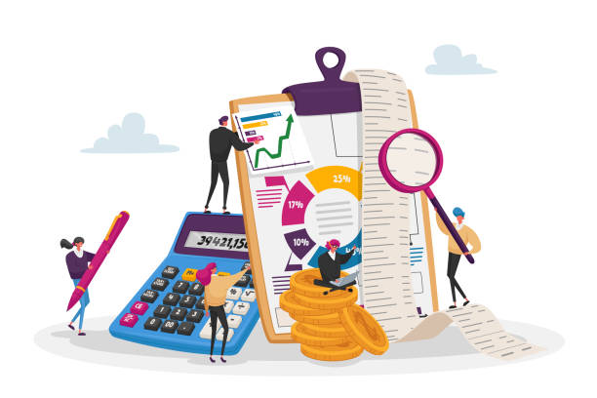

Auditing means examining the reporting produced by the company, particularly the financial statements. **The internal audit** is carried out by the company's own accountants or internal auditors. **The external audit** is done by independent auditors who are not employees of the company. Public limited companies have to submit their financial statements to external auditors.

Internal auditors examine:

* The company’s **system of control**. The auditors examine whether the internal procedures established by the company are consistent and sufficient. They check whether the procedures guarantee the traceability of information or transactions and whether they make it possible to prevent probable fraud. The auditors also check whether these procedures are rigorously followed by staff.
* **The accuracy of accounts.** Auditors check for errors and make sure that accounts comply with established policies and standards. They look for possible fraud, where the company may have deliberately given false information. If necessary, auditors make recommendations.

External auditors do the same functions as internal ones. They examine **the truth and the fairness of financial statements**. They try to prevent what is called **creative accounting**, which means recording transactions and values in a way that produces a false result, usually an artificially high profit. They also check whether the assets mentioned in the balance sheet actually exist and whether their valuation is correct, if the debtors recorded are genuine, if the stock take – the count of all goods held ready for sale – are correct. They always look for any unusual items in the accounts.

**Comprehension:**

* Is there a difference between internal and external audit?
* Which companies are obliged to audit their accounts? Why?
* What are the likely consequences of non-compliance with internal procedures?
* What is the creative accounting?

**Vocabulary:**

1- Find in the text synonyms of these words: correctness, follow, inspection, verify, mission, state.

2- Complete the following table.

|  |  |  |
| --- | --- | --- |
| **Verb** | **Noun** | **Adjective** |
|  |  | Accurate |
|  | Compliance |  |
| To recommend |  |  |
|  | Record |  |
|  | Examination |  |

3- Someone is explaining a company’s owner what is internal audit and what it aims for, complete his definition with one of these words: it - on – as - your – some - to - there - within - and - or – an - while

Internal audits take place ………………your business. …………the business owner, you initiate the audit …………….someone else in your business conducts……………... Businesses that have shareholders ………….board members may use internal audits as a way …………..update them on their business’s finances. Internal audits are a good way to check in ………….financial goals. Although …………..are many reasons you may conduct ……………internal audit, …………..common reasons include to:

* Propose improvements.
* Monitor effectiveness.
* Make sure ……………business is compliant with law and regulations.
* Review and verify financial information.
* Evaluate risk management policies ………….procedures.
* Examine operation processes.

**Grammar**: ***Present Simple***

How we write verbs in present simple.

|  |  |
| --- | --- |
| Cases | Examples |
| With : she, he, it : we add **s** | Internal auditor **checks** for errors |
| In the negative form, we add the verb **do + not** (I, you, they, we)  **does + not** (she, he, it) | Shareholders **do not manage** their company. |
| In the interrogative form. | **Do** the directors **meet** next week? |
| Verbs ending in **y,** with third person, the **y** changes into **ies.** | To cry – he **cries** |
| If there's a vowel before **y**, we just add : **s.** | he **plays.**  she **enjoys.** |
| Verbs ending in: **ss – ch – sh – x**, we add **es.** | He **passes**, she **catches**, it **fixes**, it **pushes**. |

The present simple is not used to express actions happening now, we rather use present continuous. The present simple is used only in these cases :

|  |  |
| --- | --- |
| To express :   1. Habits, 2. General truths, 3. Unchanging situations, 4. Emotions and wishes. | 1. I smoke. 2. The sky is blue. 3. I take the bus every day. 4. I wish I can find a job. |
| To give instructions and directions. | You walk for two miles then you turn left. |
| To express fixed arrangement present or future. | Your exam starts at 9.00. |
| To report what we have heard or what we have read. | This newspaper article explains why unemployment has been rising so quickly. |
| To express future time after some conjunctions: after, before, until, when, as soon as. | We will give it to her once she arrives. |
| With performative verbs that perform the action they describe like: accept, acknowledge, advise, apologize, assume, deny, guarantee, hope, inform, predict, promise, recommend, suggest, suppose, and warn. | Internal auditors recommend changing procedures. |