**Unit 3: Public sector accounting**

“There is no good wind for those who don’t know where they are sailing”

Seneca, Stoic philosopher, 4 BC- 65 AC

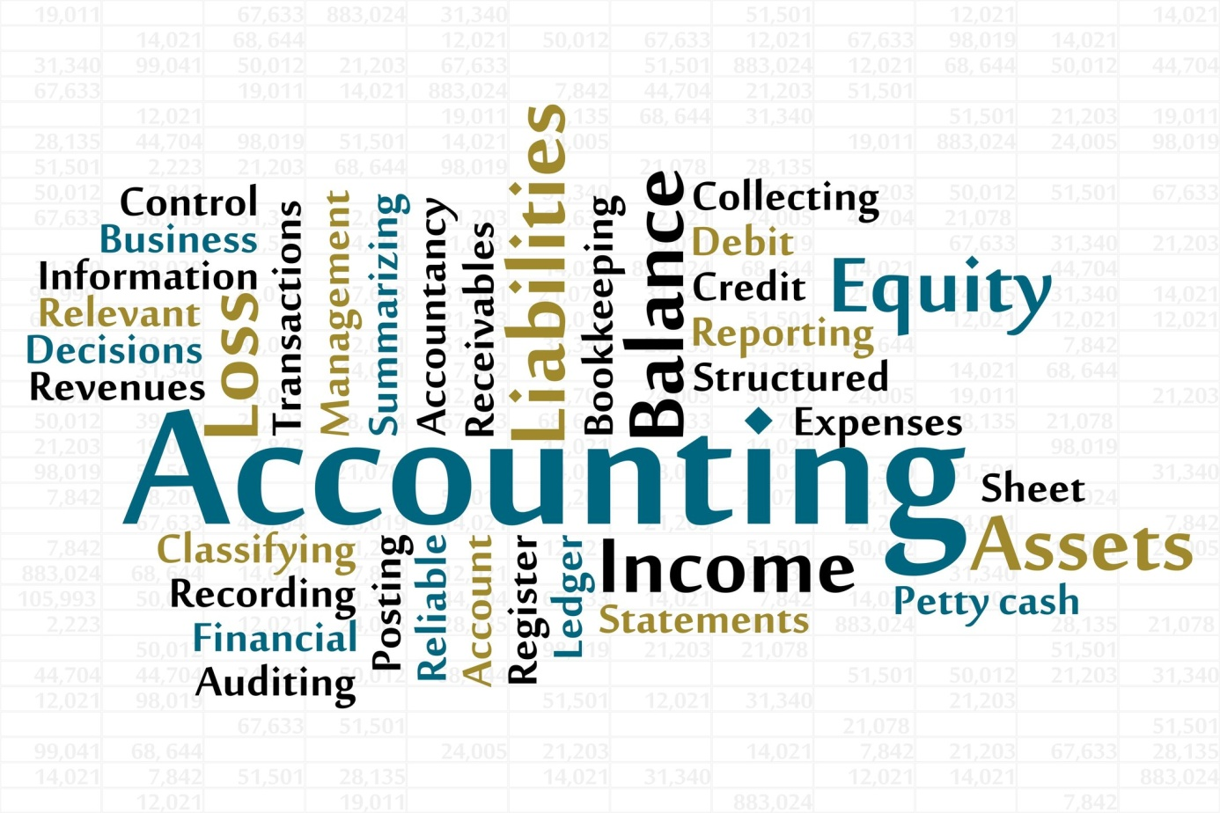

**National income accounting** is a government bookkeeping system that measures a country's economic activity offering insight into how an economy is performing. Such a system will include total revenues by domestic corporations, wages paid, sales and income tax data for companies.

**Sector accounts** consist of financial and non-financial accounts. They link financial and non-financial statistics, thereby allowing for an integrated analysis of non-financial economic activities (such as gross fixed capital formation) and financial transactions (such as the issuance of debt). These sectors are households, businesses, government, and foreign trade.

**The public sector accounting** is an information system designed to measure financial information (transactions) of public sector organizations for purposes of the planning, appraisal, reporting, evaluation and management of organizations. It provides information on the availability and allocation of resources; which helps decision-makers allocate resources effectively and efficiently. It helps ensure that public resources are allocated to programs and services with the greatest impact.

**Comprehension:**

* Why is the public sector accounting important?
* What are the sectors accounts?
* How to measure a country’s economic activity?

**Grammar**: ***Determiner: definite and indefinite articles II***

*Indefinite article:* **A/An**

- We use: - «**a** » with nouns starting with consonants,

- **an** with nouns starting with vowel (a, e, i, u, o).

***But***

- We use « **an** » before a **h mute**: an hour, an honour, an heir (a person who inherits money etc., when someone dies).

- We use « **a**» before **u or eu** when they sound “**you”**: a university, a unit, a European…

- We use « **an** » with abbreviations said as individual letters: an FBI agent.

- And « **a** » with abbreviations said as words: a NATO general.

|  |  |
| --- | --- |
| **We use a/an** | **Examples** |
| 1. To refer to something for the first time | A man went to the bank. |
| 2. With names of job.  But: when we have a list of nouns in apposition, we don’t add article. | He is a manager.  Olivia Ford, actress, charity worker, campaigner, died yesterday. |
| 3. With nationality or religion. | He is an Englishman.  She is a catholic. |
| 4. With names of days. | I was born on a Tuesday. |
| 5. To refer to a kind of or to an example of something. | It was a very big company. |
| 6. With little (for uncountable nouns) and few for (countable). The meaning when using **a little/a few** is « *some »*. The meaning changes to « *almost any* » without article. | - She needs a little attention (she has no attention and she needs some).  - She needs little attention (she has some attention but there’s no need to give her more).  - They have a few paintings (some).  - They have few paintings (almost any). |
| 7. Meaning one or as a preposition. | I would like an orange (one orange).  The onions are 60 DA a kilo. |