**Unit 5 : People in meeting**

« Nearly all men can stand adversity, but if you want to test a man's character, give him power. »  
Abraham Lincoln, 16th President of the United States, 1809-1856

Some animals in the forest decide to hold a meeting in ordre to discuss how to kill their king or any other issu. Look at the picture and try to answer questions below :

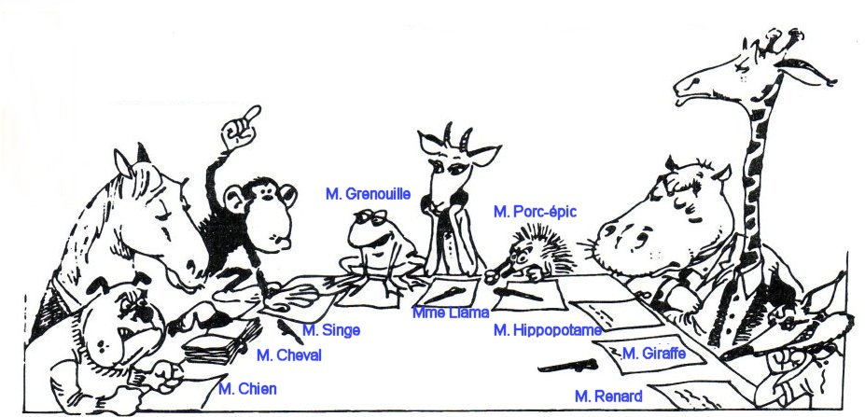

These 9 animals, according to their character, represent the kinds of people, one can expect to deal with in any meeting. So here are names of these animals, match each one with the appropriate person it may represent, according again to its character.

Talkative Dog

Sorehead Horse

Wise Monkey

Foxy Frog

He knows everything Gazelle

Lord Porcupine

Brawler Hippotamus

Tender Giraffe

He’s against Fox

Now try to find how to behave face to each person. Select the appropriate strategy to adopt with participants.

1.Keep calm, do not provoke him He knows everything

2.Take advantages of his orientations Sorehead

3.Encourage the group to undermine his theories Wise

4.Interrupt him with tact, try to limit his speaking time Foxy

5.Make him more confident, ask him easy questions and Talkative

be impressed about each interesting thing he said

6. Limit your discussion with him Lord

7. Pay attention to his favourite topics Brawler

8. Do not criticize him, use « Yes, but…. » to say no Tender

9. Foil his plan and argument He’s against

Now imagine that other animals join the meeting like: a cat, lion, parrot, bear, chameleon, shark. What could be their character?

1. He waits for the others to bring what to eat.
2. He’s not sociable.
3. He falls on his paws.
4. He changes his minds easily.
5. He repeats all what he heard.
6. Predator, his presence is just for himself.

One can have to deal with very different people, in work or in daily life, not just in meeting. It’s important to know what are their characters in order to have the appropriate behavior. In company, the aim is to avoid conflicts and reach agreement that could meet employees’ expectations.

**Activity :** Complete this table

|  |  |
| --- | --- |
| Verb | Noun |
| To manage |  |
|  | Association |
| To direct |  |
|  | Orientation |
| To compete |  |