**Unit 5: Accounting, principles and assumptions**

“May I be given the strength to accept what cannot be changed and the courage to change what can,

but also the wisdom to distinguish the one from the other”,

Marcus Aurelius, Roman emperor and a Stoic philosopher, 121-180 AC.

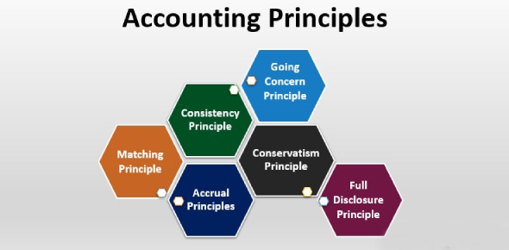

Accounting involves recording and summarizing a company’s transactions or business deals such as purchases or sales and reporting them in the form of financial statements. The accountancy profession has a professional organization, which regulates the working of accountants and operates their training. It also makes ethical rules, which are accepted ways to practice the profession. Accounting record requires considering a set of principles, in order to guarantee that accounts are being recorded correctly. These are the following:

* **Separate entity:** a business is an accounting unit separated from its owner, creditors and managers and their assets. These people can all change but the business continues as before.
* **Unit of measure:** all financial transactions are in a single currency. Companies with subsidiaries in different countries have to convert their results into one currency in a consolidated financial statement for the whole group of companies.
* **Full-disclosure:** financial reporting should include all significant information, anything that makes a difference to the users of financial statements.
* **Time period:** the economic life of a business can be divided into artificial periods such as a financial year or a quarter of it.
* **Conservatism:** if there are different accounting methods, the accountant chooses the one that is least likely to overstate assets or income.
* **Matching principles:** each cost or expense related to revenue earned must be recorded in the same accounting period as the revenue it helped to earn.
* **The revenue recognition:** the revenue is recognized in the accounting period in which it is earned. The revenue is recorded when a service is provided or when good is delivered, not when they are paid for.
* **Objectivity:** accounts should be based on facts, not on personal opinions or feelings. Accounts should be verifiable. Auditors should be able to recognize that they are true. This isn't always possible, depreciation or provisions for bad debts, for example, are necessarily subjective, based on opinions.

**Comprehension:**

1. Do you think the accountancy profession independent?
2. What is the role of professional accountancy organization?
3. Are accountants allowed to over-estimate assets or income? Why?
4. Can accountants be objective? Why?

**Vocabulary:** find in the text synonyms of these words: verifiable, recognition, gain, to have need of.

**Grammar:**  ***Pronouns***

A pronoun usually refers to something already mentioned in the text in order to avoid repetition. Here are all kinds of pronouns:

|  |  |  |  |  |  |  |  |
| --- | --- | --- | --- | --- | --- | --- | --- |
| Subject | I | You | He | She | It | We | They |
| Object | Me | You | Him | Her | It | Us | Them |
| Possesive adjective (determiner) | My | Your | His | Her | Its | Our | Their |
| Possesive pronouns | mine | Yours | His | Hers | Its | Ours | Theirs |
| Reflexive and intensive pronouns | myself | Yourself  Yourselves | Himself | Herself | Itself | Ourself  Ourselves | Themselves |

Notes :

* **We** can be used either as I in formal speaking and writing.

There's often confusion over which pronoun you should use when you're one half of a dual subject or object.

* Should you say: « me and him had a fight » or « he and I had a fight »?

If we write the sentence with one pronoun we will say: « I had a fight », not «me had a fight ». Same thing goes to the object. We said «the police arrested me and him», not « the police arrested I and he ».