**Unit 7: Financial statements**

“The two most powerful warriors are patience and time”

Leo Tolstoy, Russian writer, in “War and Peace”, 1828-1910.

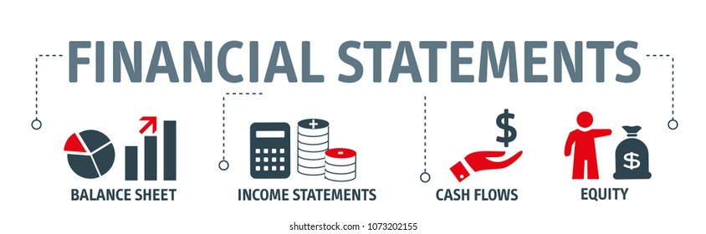

Financial statements are reports containing data that give insight into the financial situation of a company. They include balance sheet, [income statement](https://venngage.com/blog/financial-statements/#income-statement), cash flow statement and [statement of change in equity](https://venngage.com/blog/financial-statements/#equity).

**The balance sheet** is a document with two halves; the totals of the both are the same, so they balance. One-half shows the business's **assets**, which are things owned by the company. The other half shows company's **liabilities** and its capital or **shareholders’ equity**. Liabilities are obligations to pay other organizations or people money that the company owes or will owe at a future date.

**The income statement** shows how much money is going in and out of the business through revenue and expenses. It shows **the gross profit** and details all operating expenses, such as office staff and marketing costs, to give a final **net income** amount. Comparing the income statement with previous years can show where resources have been allocated and help explain any changes in profitability.

**The cash flow statement** shows how changes in income and the balance sheet accounts impact cash. The items are broken down into **operating, investing and financing activities**. This is important to show the difference between a cash increase from sales and a cash increase from taking out a loan.

**The statement of changes in equity** reconciles the balances of the companies’ beginning and ending amount of equity during a reporting period.

**Comprehension:**

* What are the main components of the balance sheet?
* How can we get the gross profit?
* Is it possible to compare the net income through the years if the company changes its accounting method?
* Give the difference between the net income and the cash flow?
* What are the company's cash-generating activities?

**Vocabulary:** find in the text synonyms of these words: variations, to affect, element, to allot, to decompose.

**Grammar*: The present perfect***

1- Present perfect form: the present perfect of any verb is composed of two parts: The ***auxiliary verb to have*** (present tense) + ***the past participle*** of the main verb.

The past participle of a regular verb is ***base + ed***. For irregular verb, we refer to the table of irregular verbs.

Negative form: Subject + to have + not + past participle.

Interrogative form: to have + Subject + past participle

E.g., she ***has arrived;*** I ***have taken***…. They ***have not finished*** yet, ***have*** you ***visited*** Paris?

2- Present perfect function: the present perfect is used to indicate a link between the present and the past. The time of the action is before now but not specified (perhaps we don't know, or it is not important to say when it happened). The present perfect is used in the following cases :

|  |  |
| --- | --- |
| Cases | Examples |
| An action or situation that started in the past and continues in the present. | I have lived in Boumerdes since 1985 (and I still do). |
| An action performed during a period that has not finished yet. | She has been in the cinema twice this week (and the week isn't over yet). |
| A repeated action in an unspecified period between the past and now. | They have visited Portugal several times. |
| An action that was completed in the very recent past. (expressed by just) | I have just finished my work. |
| An action when the time is not important. Only matter the results of the action. | She has read « War and peace ».  He has learnt English, Russian and French. |
| When something that happened in the past affects the situation that exists now. | I've washed my hands so that I can help you with the cooking. |