**Unit 6: Accounting, policies and standards**

“Those who know how to be patient do not need to make concessions”

Sigmund Freud, founder of psychanalysis, 1856-1939.

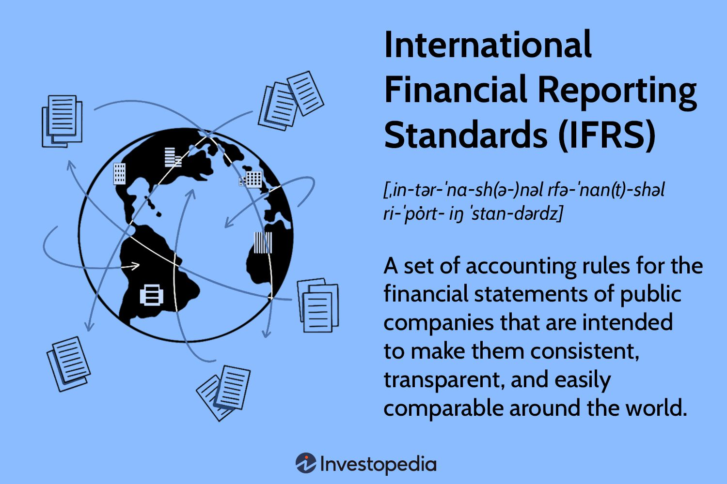

Companies can choose their accounting policies – ways of doing accounts – in order to know how much the company is worth, and to calculate their profits. In the USA, policies are named **GAAP** (**Generally Accepted Accounting Principles)**. In most of the rest of the world, companies follow the **IFRS (International Financial Reporting Standards)** set by the international financial standards board. These are technical rules and conventions – accepted ways of doing things that are not written down by the law.

Companies can choose among different accounting policies but they have to be consistent, which means using the same method every year, unless there's a good reason to change policy. This is known as the **consistency principle**. The policies have also to be revealed to the shareholders, the annual report should contain a statement of accounting policies that mentions any changes have been made. Therefore, shareholders could compare the profits with those made the previous year.

Sections in which the choice of the policy can make a big difference are: depreciation, the valuation of stocks or inventory, the provisions for future pension payments and the value of assets. Actually, in many countries, accounting follows **the historical cost principle** – assets are recorded according to their **original purchase price** and not their estimated or **current selling prices**. However, some countries with regular high inflation use **replacement cost accounting**, which values all assets at their **current replacement costs** – the amount that would have to be paid to replace them now. Anyway, no matter what policy the company chooses, it should give a true and fair view of the financial situation.

**Comprehension** :

1. What are the accounting policies?
2. Who made the IFRS?
3. Are companies allowed to choose their accounting policy?
4. What is the consistency principle?
5. How can the choice of policy make a difference in calculating profits?
6. What are the methods used to record assets?
7. What are the different prices used to value assets?

**Vocabulary**: find in the text synonyms of these words: system, agreement, to disclose.

**Grammar:** ***Reflexive and intensive pronouns***

***Reflexive pronouns*** refer back to the subject because the subject of the action is also the direct or indirect object. Only certain types of verbs can be reflexive. You cannot remove reflexive pronoun from a sentence because the remaining sentence will be grammatically incorrect. I told **myself** to calm down.

***Intensive pronouns*** emphasize the subject of a clause. They are not the object of the action. They can be removed without changing the meaning of the sentence. Intensive pronouns can be placed immediately after the subject or at the end of the sentence. I made these cookies **myself**.

Here are 4 cases where we should use reflexive pronouns.

1. We use a reflexive pronoun with **transitive verbs**, as a **direct object** when the **object** is the same **subject** of the verb:

* Be careful with that knife, you might **cut** **yourself.**

The most common transitive verbs are: enjoy, dry, amuse, blame, hurt, introduce, prepare, satisfy…. We do not use reflexive pronouns after verbs which describe things people do obviously for themselves: dress, shave, wash.

* He always **shaves** ~~himself~~ before going to work.

We only use reflexive with these verbs for emphasize:

* She **dressed herself** in spite of her injuries.

2. We use reflexive pronouns as an **indirect object** when the **object** is the same as the **subject**.

* We have brought **ourselves** something to eat.

3. As an object of a preposition when the object refers to the subject of the clause.

- He was feeling very sorry for **himself.**

4. With the preposition by if we want to show that someone did something alone.

- He walked home by **himself.**

- She lived by **herself** in an enormous house.

**Note:**

We don't use Reflexive pronouns after a preposition of place:

* He had a big opportunity beside **him**.

After with when it means accompanied by:

* I have few friends with **me**.