**Unit 7: Accounting, the bookkeeping**

« There are two kinds of power, the one you have on yourself and the one you have on the others, and if you don’t have power on yourself someone else, or something has it”

Marcus Aurelius, Roman emperor and a stoic philosopher, 121-180 AC

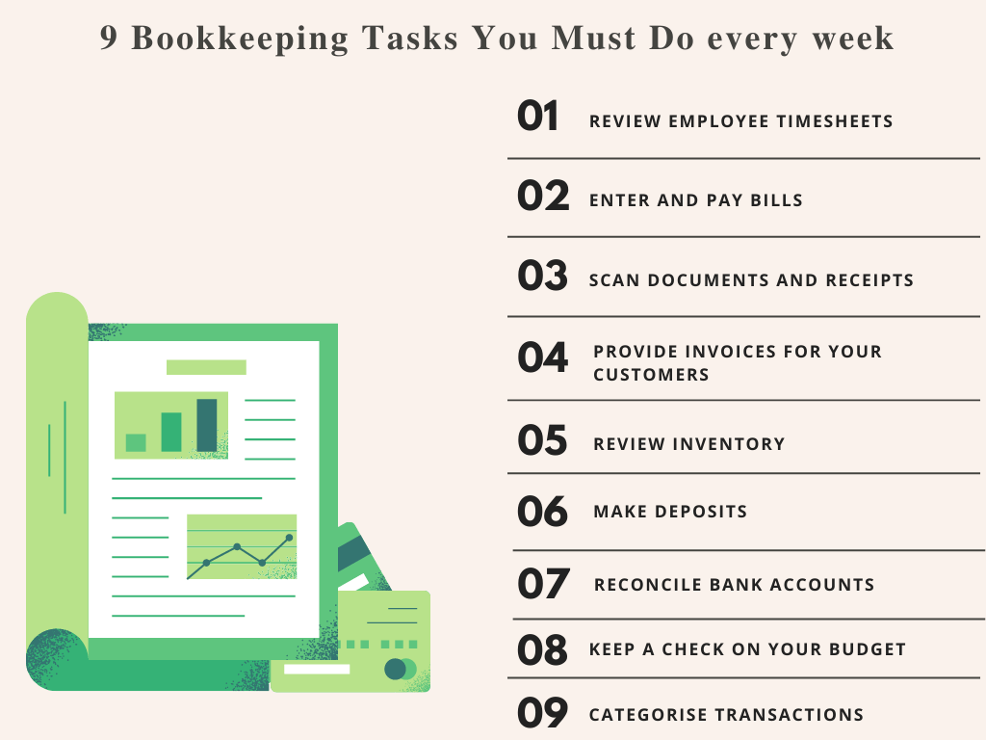

Bookkeeping is the day to day recording of transactions or activities. The bookkeeper records the company's daily transactions: sales, purchases, debts, expenses… Double entry-bookkeeping is a system that records two aspects of each transaction. Every transaction is both **a debit**- deduction- in one account and a **credit** – an addition- in another account. If a company buys some raw material that it will pay for a month later, it debits its purchase account and credits its suppliers account. If the company sells goods on credit, it debits its sales account and credits its customers account. Each account can be debited or credited. If the bookkeepers do their work accurately, the total of the debits always equal to the total of credits.

For accounts with a large number of transactions, like purchases or sales, companies often records transactions in **day books** or in a **journal**, and then put a daily or a weekly summary in the main double-entry records.

In Britain, the main books of account are named **nominal ledgers.** The terms of **debtors** and **creditors** can refer to both businesses and money. Debtors can be companies that owe money or just the sum of money recorded in an account.

**Comprehension:**

1. What is the double entry bookkeeping?
2. Can each account be debited or credited?
3. How to record big accounts?
4. What if the bookkeeper misses to debit an account?
5. What does the term “creditors” mean?

**Vocabulary:**

1- Find in the text synonyms of these words: correctly, affair, to be in debt, to write down, accounts receivables, accounts payables.

2- Fill in the gaps with the right word: objectivity – issuing - multinational - investing - recorded – check.

* Every transactions made by the company must be………………… There must be a document to show that it's true.
* …………………..with its subsidiaries, combines all their results in a set of consolidated financial statement.
* Both internal and external auditors have to ………………company's accounts.
* Despite the……………....principle, accountants have to make some subjective judgment.
* ........…………… means spending cash for the future business’ growth, including cash acquired from selling assets.
* Financing involves raising money by ….………………stocks and bonds.

3- In each set of words, cross out the word that does not have a similar meaning to the first.

|  |  |  |  |
| --- | --- | --- | --- |
| Acquire | Get | Obtain | Ask |
| Allocate | Assign | Take | Give |
| Alternative | Change | Option | Possibility |
| Commodity | Item | Market | Product |
| Consumption | manufacture of items | purchase of items | use of items |
| Fundamental | Basic | Essential | Secondary |