**Unit 8 : Accounting policies and standards**

« If you want to ge fast, go alone, if you want to go far, go together », African proverb.

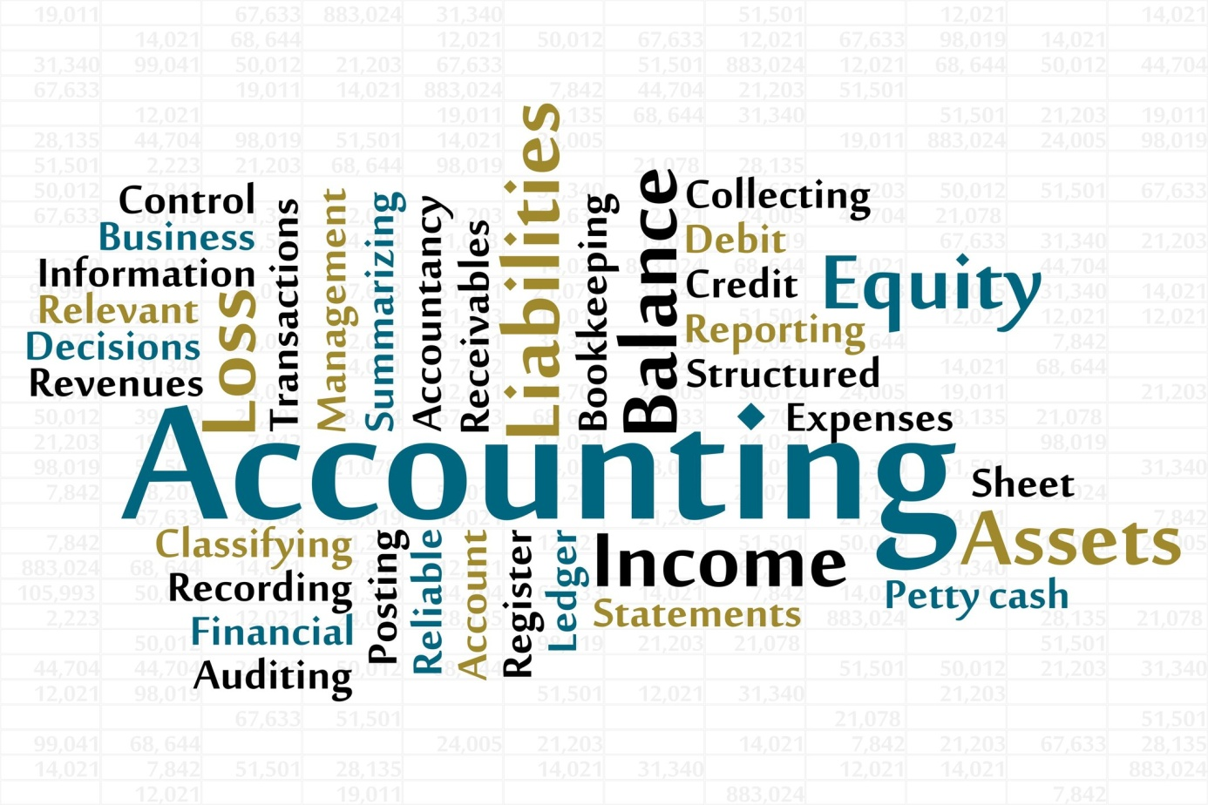

Companies can choose their accounting policies – ways of doing accounts – in order to know how much the company is worth, and to calculate their profits. In the USA, there are **Generally Accepted Accounting Principles** (**GAAP**). In most of the rest of the world, there are **International Financial Reporting Standards (IFRS)** set by the international financial standards board. These are technical rules and conventions – accepted ways of doing things that are not written down by the law.

Companies can choose among different accounting policies but they have to be consistent, which means using the same method every year, unless there's a good reason to change policy. This is known as the **consistency principles**. The policies have also to be revealed to the shareholders, the annual report should contain a statement of accounting policies that mentions any changes have been made. Therefore, shareholders could compare the profits with those made the previous year.

Sections in which the choice of the policy can make a big difference are : depreciation, the valuation of stocks and inventory, the provisions for future pensions payments and the value of assets. Actually, in many countries, accounting follows **the historical cost principle** – assets are recorded according to their original purchase price and not their estimated or current selling prices. However, some countries with regular high inflation use **replacement cost accounting**, which value all assets at their **current replacement costs** – the amount that would have to be paid to replace them now. Anyway, no matter what policy the company chooses for their accounts, they should give a true and fair view of the financial situation.

**Comprehension** :

1. What are the accounting policies ?
2. Who made the IFRS ?
3. Are companies allowed to choose their accounting policy ?
4. What is the consistency principle ?
5. How can the choice of policy make a difference in calculating profits ?
6. What is the difference between historical cost principle and replacement costs accounting ?

**Vocabulary** :

Exercise 1 : matches the two parts of sentences :

1. Companies’ managers, investors, creditors and the tax authorities all
2. There are different ways of doing accounting but companies have to be consistent
3. Companies have to disclose or make known
4. The historical cost principle is that the price paid to buy assets
   1. And not their current value, is recorded in the accounts.
   2. Need to know about the size of profits or losses.
   3. Which accounting method they are using
   4. Which means regularly using the same methods.

Exercise 2 : Complete this table.

|  |  |  |
| --- | --- | --- |
| Verb | Noun | Adjective |
|  | Calculation |  |
|  |  | Consistent |
|  |  | Conventional |
| Measure |  |  |
| Present |  |  |
|  |  | Valuable |

Exercise 3 : find in the text synonyms of these words : system, valuation, agreement,

**Grammar :** *The present continuous / the present progressive*

1. *Present continuous form is composed of two parts :*

The **present simple** of the verb to **be** + **the present participle** of the verb

I **am talking**, she **is walking**, we **are playing**…..

Negative form : you are not waiting for him.

Interrogative form : is he going ?

1. *Present continuous functions :*

As with all tenses in English, the speaker’s attitude is as important as the time of action or events. When we use the present continuous, the action is unfinished or incompleted.

Here are cases where we use present continuous

|  |  |
| --- | --- |
| Cases | Examples |
| To describe an action that is going on at this moment | You are studying English grammar |
| To describe an action that is going on during this period of time or a trend | I am still working for the same company |
| To describe an action or an event in the future which has already been planned | We're visiting the museum tomorrow. |
| With always, forever, constantly, to describe and emphasise a continuing series of repeated actions. | They are always arguing. |

1. Verbs that are not used in the present continuous : all verbs that refer to states, rather actions or processes

|  |  |
| --- | --- |
| Sense / perception | Smell, feel, hear, see, taste |
| Opinion | Think, assume, believe, consider, doubt, find, suppose. |
| Mental states | Forget, imagine, know, mean, notice, recognise, understand, remember |
| Emotions / desire | Envy, fear, dislike, hate, hope, like, love, mind, prefer, want, wish |
| Measurement | Contain, cost, hold, measure |
| Others | See (when it means plan)  I' m seeing John tonight (it's planned to see him)  Have (when it doesn't mean possess)  She's having supper (she's eating) |

**Activity 1:** Here you have a part of an interview between a journalist and an expert in management, choose the right answer:

* If we talk about the Japanese management, what could you tell…………. ? (him, she, us)
* Before giving you the answer, first I would like to correct a big fallacy concerning names given to………………… kind of management when it’s not an American one (every/each). You can………………….hear something like “American management” (never/ever). Why people tend to consider that the management as a science is essentially American and any other kind of management is specific to the country…………….it is exercised ?(when/who/where). This…………… us to another big misunderstanding (leading/leads/lead), which is the idea that Japanese, German or Korean management can only exist in those countries, and no other company can adopt it, while the American management can…………………be adopted (easy/easily).
* I have to admit…………it is a precious observation (that/this), we all use to……………. that management is created by American people, but it is not (thinks/think/thinking).
* Of course, management is just the way to run a business, and people all around the world, long before the United States was…………… as a nation, managed their business according to their wisdom (found, founded, founding). In fact, wisdom is just what one should have to become good manager.

**Activity 2:** Match each word with its synonym

* Company To display
* Capital Owners
* Shareholders Firm
* To manage Funds
* To show To run

**Activity 3:** find each adjective

a……………… ……. h……………….. a……………………

h……………………. fa…………………. Lo……………………..

fa…………………… lo…………………. Da……………………..

str………………….. da…………………. Str………………………

s…………………… t…………………… s…………………………

t……………………

iped- ired- uge- errible- mous- orrible- ong- mazing- oft- wake- ud- vely- potted- t- rk- ngerous

**Activity 4:** Match the rhyming words :

They’re choose

We’re gets

He’s near

I am don’t

Who’s air

Let’s knees

Won’t time

**Activity 5:** Circle the correct word:

* It’s cold. I need to put on my **coat/goat**.
* The explorers found a **cave/gave** in the mountains.
* Put your hat and coat in the **hall/call**.
* Kate and john **came/game** to the football match.
* Our teacher said the plate was made of **class/glass**.
* The actor let me **hold/gold** the prize he won.
* He was swimming at the beach when it **got/hot** windy.
* She won a **cold/gold** metal at the Olympic Games.

**Activity 6:** Complete this table

|  |  |  |
| --- | --- | --- |
| Infinitive | Past simple | Past participle |
|  |  | Found |
| To give |  |  |
|  | Let |  |
| To drive |  |  |
|  | Felt |  |

**Activity 7:** Complete this table

|  |  |
| --- | --- |
| Verb | Noun |
| To confirm |  |
|  | Production |
| To organize |  |
|  | Education |
| To qualify |  |

**Activity 4:** Match each word with its synonym

check Inventory

earning Factory

statement Examine

plant Profit

stock Document