**Unit 6: Forensic accounting**

“If we take care of the moments, the years will take care of themselves”,

Maria Edgworth, English writer, 1768-1849.

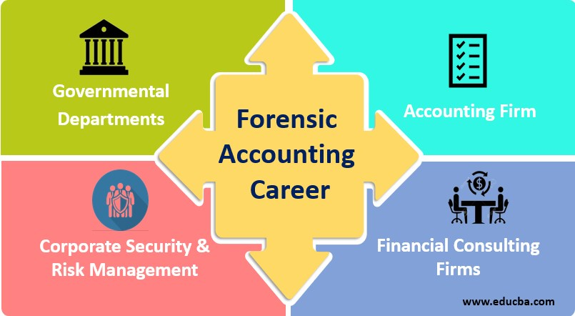

Forensic accounting is a kind of auditing that “follows the money” and analyzes financial information to look for potential evidence of crimes. Forensic accountants investigate companies’ and people financial records, they use accounting and legal skills to interpret and communicate their findings to others.

Forensic accountants use accounting, auditing, and investigative skills to understand whether a person or company has committed financial misconduct, such as embezzlement or fraud. They determine if financial activity is illegal and often present their findings in court.

Forensic accountants can work in a variety of sectors, whether in public practice or for insurance companies, banks, police forces, or government agencies.  
 Qualifications required for general accountants and forensic accountants are similar, but a forensic accountant must have a more skeptical mindset and should have a general understanding of the legal system. Other skills are very important:

* Fraud investigation.
* Data analysis.
* Internal and external auditing techniques.
* [Writing skills](https://www.theforage.com/blog/skills/what-are-writing-skills).
* Investigate skills.
* Interrogative skills.

**Comprehension:**

* What is the main mission of forensic accounting?
* Why is it different from auditing?
* Do you think forensic accountant should be highly skilled?
* Does audit report have relevance in court?

**Vocabulary:** find in the text synonyms of these words: questioning, to inspect, competency, results.

**Grammar :** ***The present continuous / the present progressive***

1. *Present continuous form is composed of two parts:*

The **present simple** of the verb to **be** + **the present participle** of the verb

I **am talking**, she **is walking**, we **are playing**…..

Negative form : you **are not waiting** for him.

Interrogative form : **is** he **going**?

1. *Present continuous function:*

As with all tenses in English, the speaker’s attitude is as important as the time of action or events. When we use the present continuous, the action is unfinished or uncompleted.

Here are cases where we use present continuous.

|  |  |
| --- | --- |
| **Cases** | **Examples** |
| To describe an action that is going on at this moment. The action has begun but has not ended at the time of speaking. | You are studying English grammar. |
| To describe an action that is going on during this period of time or a trend. | I am still working for the same company. |
| To describe an action or an event in the future that has already been planned. | We are visiting the museum tomorrow. |
| With always, forever, continually, constantly, to describe and emphasize a continuing series of repeated actions that we are unhappy about. | They are always arguing. |
| With time expressions such as at the moment, at present, currently, just, and still to emphasize that the action or event is happening now. | I’m just going. |
| To imply that a situation is or may be temporary. | - Banks lend money to make a profit, (this is their main mission).  - Banks are lending more money (these days) to encourage investment (it is a temporary situation). |
| To talk about changes, developments, and trends. | The growing number of visitors is damaging the footpaths. |
| To describe longer or background events when we tell a story.  **Note:**  For the main events, we use the present (or past) simple. | She goes up to this man and looks straight into his eyes. She is carrying her bag. |