Unit 8 : Accounting policies and standards
« If you want to ge fast, go alone, if you want to go far, go together », African proverb.
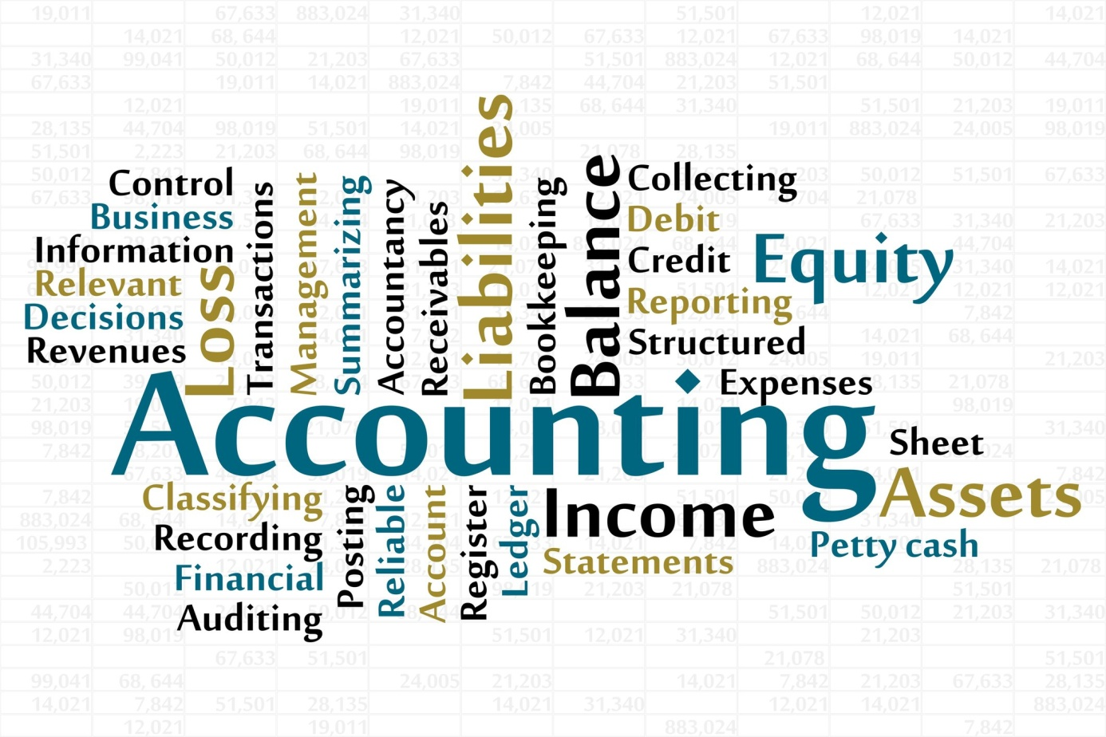
Companies can choose their accounting policies – ways of doing accounts – in order to know how much the company is worth, and to calculate their profits. In the USA, there are Generally Accepted Accounting Principles (GAAP). In most of the rest of the world, there are International Financial Reporting Standards (IFRS) set by the international financial standards board. These are technical rules and conventions – accepted ways of doing things that are not written down by the law.
Companies can choose among different accounting policies but they have to be consistent, which means using the same method every year, unless there's a good reason to change policy. This is known as the consistency principles. The policies have also to be revealed to the shareholders, the annual report should contain a statement of accounting policies that mentions any changes have been made. Therefore, shareholders could compare the profits with those made the previous year.
Sections in which the choice of the policy can make a big difference are : depreciation, the valuation of stocks and inventory, the provisions for future pensions payments and the value of assets. Actually, in many countries, accounting follows the historical cost principle – assets are recorded according to their original purchase price and not their estimated or current selling prices. However, some countries with regular high inflation use replacement cost accounting, which value all assets at their current replacement costs – the amount that would have to be paid to replace them now. Anyway, no matter what policy the company chooses for their accounts, they should give a true and fair view of the financial situation.
Comprehension :
- What are the accounting policies ?
- Who made the IFRS ?
- Are companies allowed to choose their accounting policy ?
- What is the consistency principle ?
- How can the choice of policy make a difference in calculating profits ?
- What is the difference between historical cost principle and replacement costs accounting ?
Vocabulary :
Exercise 1 : matches the two parts of sentences :
- Companies’ managers, investors, creditors and the tax authorities all
- There are different ways of doing accounting but companies have to be consistent
- Companies have to disclose or make known
- The historical cost principle is that the price paid to buy assets
  - And not their current value, is recorded in the accounts.
  - Need to know about the size of profits or losses.
  - Which accounting method they are using
  - Which means regularly using the same methods.
Exercise 2 : Complete this table.
Verb | Noun | Adjective
 | Calculation
 |  | Consistent
 |  | Conventional
Measure
Present
 |  | Valuable

Exercise 3 : find in the text synonyms of these words : system, valuation, agreement,
Grammar : The present continuous / the present progressive
- Present continuous form is composed of two parts :
The present simple of the verb to be + the present participle of the verb
I am talking, she is walking, we are playing…..
Negative form : you are not waiting for him.
Interrogative form : is he going ?
- Present continuous functions :
As with all tenses in English, the speaker’s attitude is as important as the time of action or events. When we use the present continuous, the action is unfinished or incompleted.
Here are cases where we use present continuous
Cases | Examples
To describe an action that is going on at this moment | You are studying English grammar
To describe an action that is going on during this period of time or a trend | I am still working for the same company
To describe an action or an event in the future which has already been planned | We're visiting the museum tomorrow.
With always, forever, constantly, to describe and emphasise a continuing series of repeated actions. | They are always arguing.

- Verbs that are not used in the present continuous : all verbs that refer to states, rather actions or processes

Sense / perception | Smell, feel, hear, see, taste
Opinion | Think, assume, believe, consider, doubt, find, suppose.
Mental states | Forget, imagine, know, mean, notice, recognise, understand, remember
Emotions / desire | Envy, fear, dislike, hate, hope, like, love, mind, prefer, want, wish
Measurement | Contain, cost, hold, measure
Others | See (when it means plan)  I' m seeing John tonight (it's planned to see him)  Have (when it doesn't mean possess)  She's having supper (she's eating)

Activity 1: Here you have a part of an interview between a journalist and an expert in management, choose the right answer:
- If we talk about the Japanese management, what could you tell…………. ? (him, she, us)
- Before giving you the answer, first I would like to correct a big fallacy concerning names given to………………… kind of management when it’s not an American one (every/each). You can………………….hear something like “American management” (never/ever). Why people tend to consider that the management as a science is essentially American and any other kind of management is specific to the country…………….it is exercised ?(when/who/where). This…………… us to another big misunderstanding (leading/leads/lead), which is the idea that Japanese, German or Korean management can only exist in those countries, and no other company can adopt it, while the American management can…………………be adopted (easy/easily).
- I have to admit…………it is a precious observation (that/this), we all use to……………. that management is created by American people, but it is not (thinks/think/thinking).
- Of course, management is just the way to run a business, and people all around the world, long before the United States was…………… as a nation, managed their business according to their wisdom (found, founded, founding). In fact, wisdom is just what one should have to become good manager.
Activity 2: Match each word with its synonym
- Company To display
- Capital Owners
- Shareholders Firm
- To manage Funds
- To show To run

Activity 3: find each adjective
a……………… ……. h……………….. a……………………
h……………………. fa…………………. Lo……………………..
fa…………………… lo…………………. Da……………………..
str………………….. da…………………. Str………………………
s…………………… t…………………… s…………………………
t……………………
iped- ired- uge- errible- mous- orrible- ong- mazing- oft- wake- ud- vely- potted- t- rk- ngerous

Activity 4: Match the rhyming words :
They’re choose
We’re gets
He’s near
I am don’t
Who’s air
Let’s knees
Won’t time
Activity 5: Circle the correct word:
- It’s cold. I need to put on my coat/goat.
- The explorers found a cave/gave in the mountains.
- Put your hat and coat in the hall/call.
- Kate and john came/game to the football match.
- Our teacher said the plate was made of class/glass.
- The actor let me hold/gold the prize he won.
- He was swimming at the beach when it got/hot windy.
- She won a cold/gold metal at the Olympic Games.
Activity 6: Complete this table
Infinitive | Past simple | Past participle
 |  | Found
To give
 | Let
To drive
 | Felt

Activity 7: Complete this table
Verb | Noun
To confirm
 | Production
To organize
 | Education
To qualify

Activity 4: Match each word with its synonym
check Inventory
earning Factory
statement Examine
plant Profit
stock Document

